Smart Alumni discovery
ABSTRACT
In olden days maintaining the old student details are not recorded but now we have many ways to store the details. One of the way is the alumni the name suggests that it contains full details old students of a particular university or any particular organizations. Many universities and organizations do not maintain the details of the students. Some problems occur if these details are not maintained. If any student of that university or organization wants to get the details of an old student, they cannot access the data. So some universities and organizations developed an application called as ALUMNI which contains the details of all the old students and presents student records. Alumni concept is not only related to students of a school or institution but also to any organizations who maintains the details of old students or employees. The details are maintained in a database, any person of that institution can access it through the database.
Introduction
As the technology is improving over days, the details are stored and can be accessed through a web site. Through these web sites the person can get the details and these websites are maintained by the particular university or school or organizations. These websites will have all the permissions and also contain other data kept by the organizations if they are interested the data may be about their university details, presentations, and advertisements and many more.
Problem Statement
The problem in the previous system is the details that are obtained are of limited data and any person is working in a company is not shown i.e.in the present status is not showed. If any person wants the details of a company that an old student works the web site will not provide the information. This is one of the problems in the existing system and another problem is, if any person visited the profile of another person’s profile. The person cannot know that how many persons are visiting their own profile. This leads to the miss use of data of that person by some other people. It means security is not provided. These are some of the problems present in the system.
Objective:
To develop an android application which takes alumni data and stores in the database.
Literature Review/ Previous work:
The problem in the previous system is the details that are obtained are of limited data and any person is working in a company is not shown i.e.in the present status is not showed. If any person wants the details of a company that an old student works the web site will not provide the information. This is one of the problems in the existing system and another problem is, if any person visited the profile of another person’s profile. The person cannot know that how many persons are visiting their own profile. This leads to the miss use of data of that person by some other people. It means security is not provided. These are some of the problems present in the system.
Proposed Work:
In the present existing system, we have some problems regarding the details of the student of that university. In the proposed work we are adding some extra features to the existing system i.e. they are adding the company details and subject matter expert fields of the old student if the person is working in a company. By using that we can easily get any expert advice or suggestions for the current student.
Approach/ Methodology:
The methodology used in this system is Agile methodology.
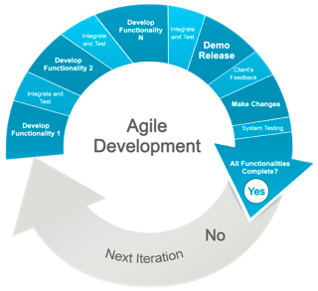http://www.gispeople.com.au/software-development/
Gantt Chart:
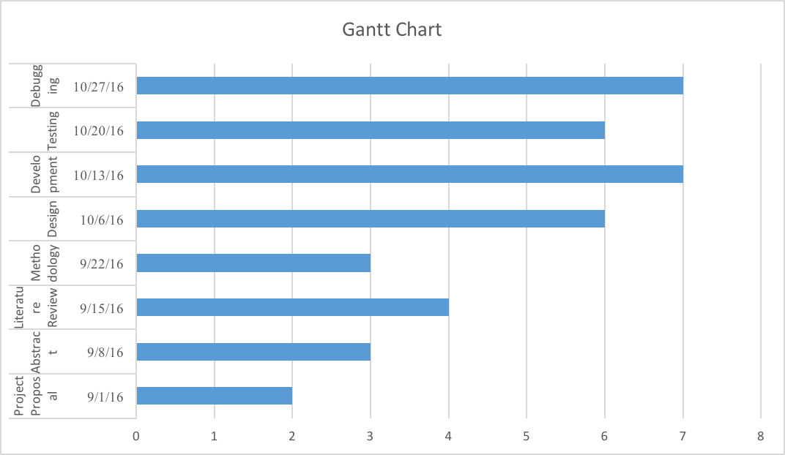

References:
- https://www.etsu.edu/125/documents/Tracking%20Alumni.pdf
- http://mitsloan.mit.edu/alumnimagazine/pdf/Winter2011-InnovativeThinking.pdf
http://web.stanford.edu/~cee/Papers/Eesley_Alumni_surveys.pdf
- https://www.humboldt-foundation.de/web/docs/F211510005/research-alumni-broschure-duz.pdf
- http://onlinelibrary.wiley.com/doi/10.1002/ss.70/epdf?r3_referer=wol&tracking_action=preview_click&show_checkout=1&purchase_referrer=scholar.google.com&purchase_site_license=LICENSE_DENIED_NO_CUSTOMER
- http://www2.deloitte.com/content/dam/Deloitte/sg/Documents/about-deloitte/sg-about-alumni-issue14-jul2015-noexp.pdf
- http://www.famu.edu/cis/Gandham_thesis.pdf

